

Data Technician

Name:
Course Date:
Table of contents
Day 1: Task 1 2
Day 2: Task 1 2
Day 2: Task 2 3
Day 2: Task 3 4
Day 3: Task 1 4
Day 3: Task 2 5
Dataset: 5
Step 1: Create a Pivot Table 5
Step 2: Use the SWITCH Function 5
Submission: 6
Day 3: Task 3 6
Day 4: Task 1 7
Course Notes 9
Additional Information 10

Day 1: Task 1

Please research and complete the below boxes on common laws and regulations that must be followed when working with customers data, use the below bulleted list to support your answers.

- What is it
- Why is it important
- Provide a real-world example of how you can follow it
- How does it impact working with data
- What could happen if you breached it

Data Protection Act | - What is it  Data protection legislation in UK that controls how your personal information is used by organisations.  - Why is it important  Protect individuals’ privacy.  - Provide a real-world example of how you can follow it  An organisation/individual would normally collect customer data e.g. name/address etc for a certain time, keeps it secure with a software and deletes after time limit.  - How does it impact working with data  DPA mandates use of data securely, transparently whilst respecting individuals’ privacy rights.  - What could happen if you breached it  Financial penalties, Action from regulators, bad reputation.
GDPR | - What is it  GDPR governs the handling of personal data and Data Protection Act.  - Why is it important  Because it strengthens privacy rights of individuals’ data and hold organisations accountable for its secure use.  - Provide a real-world example of how you can follow it  As an organisation/business, it would obtain clear consent from individuals before any marketing emails, provide clear privacy policy.  - How does it impact working with data  GDPR makes it more transparent, accountable, limited usage and enhanced security to protect individuals’ privacy.  - What could happen if you breached it  Regulatory action, fines, reputation damaged, possible lawsuits.
Freedom of Information Act | - What is it  FOI gives individuals/public a legal right to access recorded information by UK organisations mainly public authorities.  - Why is it important  FOI promotes transparency and accountability to protect individuals’ legal right to access their information stored, public spending and decisions influencing general population especially for government public authorities.  - Provide a real-world example of how you can follow it  A public authority can promptly respond to a citizen’s written request for recorded information for that individual.  - How does it impact working with data  FOI requires public authorities to publish/provide data upon request and hence necessitates secure record keeping and data handling policies.  - What could happen if you breached it  Possible regulatory action from ICO, Possible fines/criminal offence.
Computer Misuse Act | - What is it  This act makes it a criminal offense to gain unauthorised access to computer material.  - Why is it important  Because if provides legal framework to criminalise hacking, malware attacks, intentional data leaks.  - Provide a real-world example of how you can follow it  A computer professional only accessing the data they are authorised to access, using data systems for intended purpose only.  - How does it impact working with data  Data professional/s are compelled to have secure measures for data handling/storage and specific purpose use.  - What could happen if you breached it  Fines, criminal prosecution, losing job.

Day 2: Task 1

Please research and complete the following tasks within the retail-sales_dataset.xlsx document, paste a print screen into the provided boxes below:

- In the sheet ‘retail_sales_dataset’ add all available data between columns A – J into a ‘Table’. Remember to select only the data you want to convert.
- Using the dropdown menu in the ‘Age’ column, sort the data by age, ‘largest to smallest’
- Using the ‘SUM’ function, show me the commission total in cell ‘M10’
- Using the ‘AVERAGE’ function, show me the average commission in cell ‘M11’

Print screen 1 | 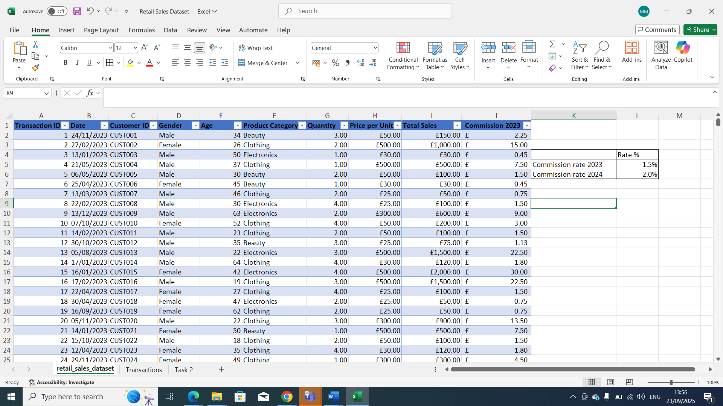
Print screen 2 | 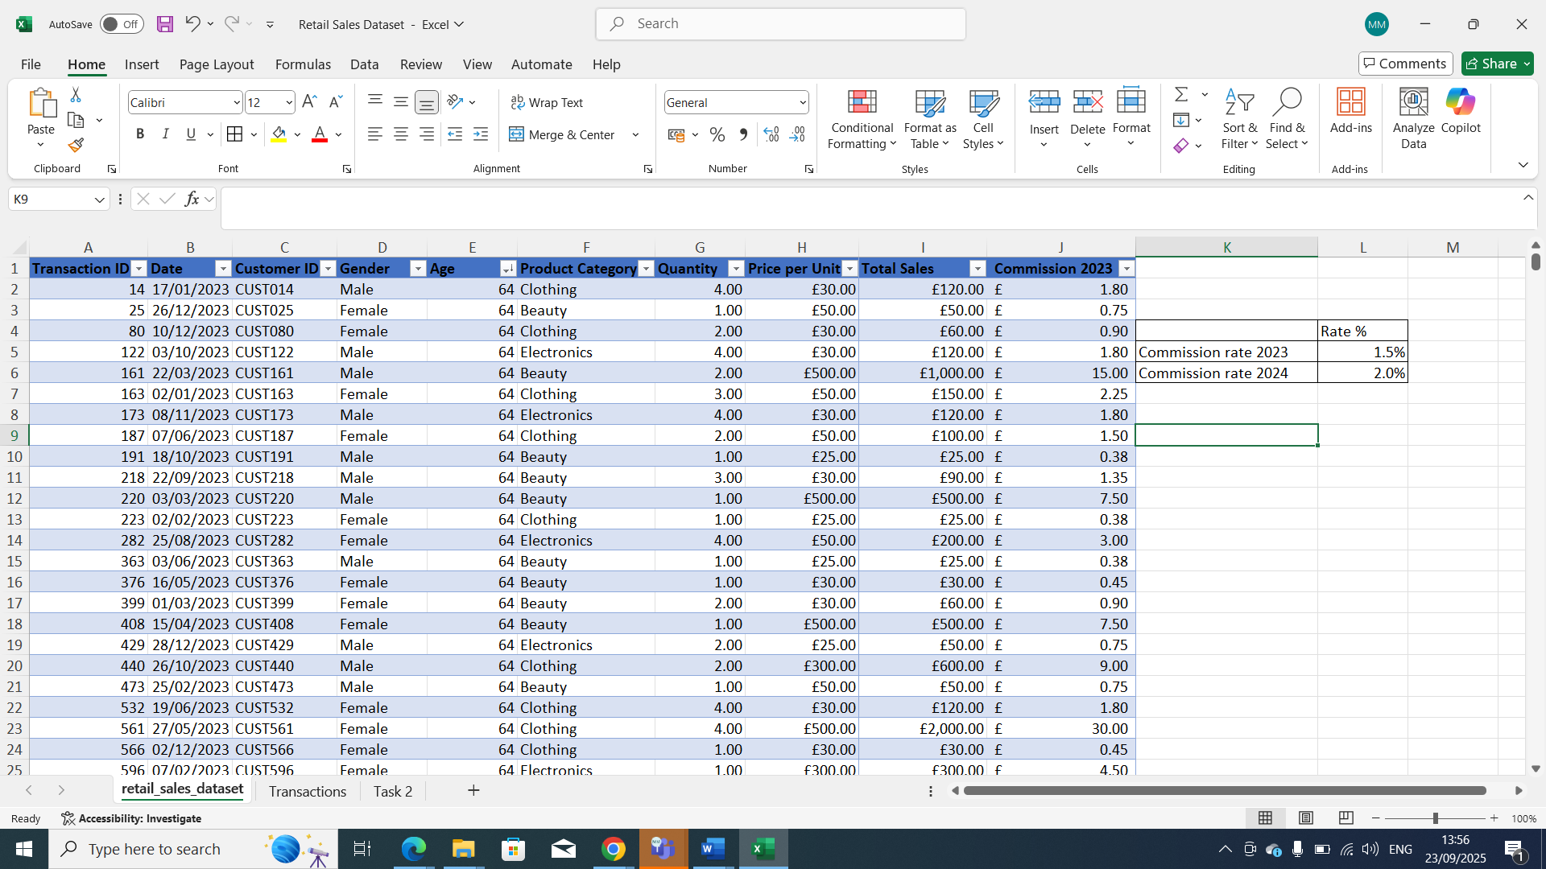
Print screen 3 | 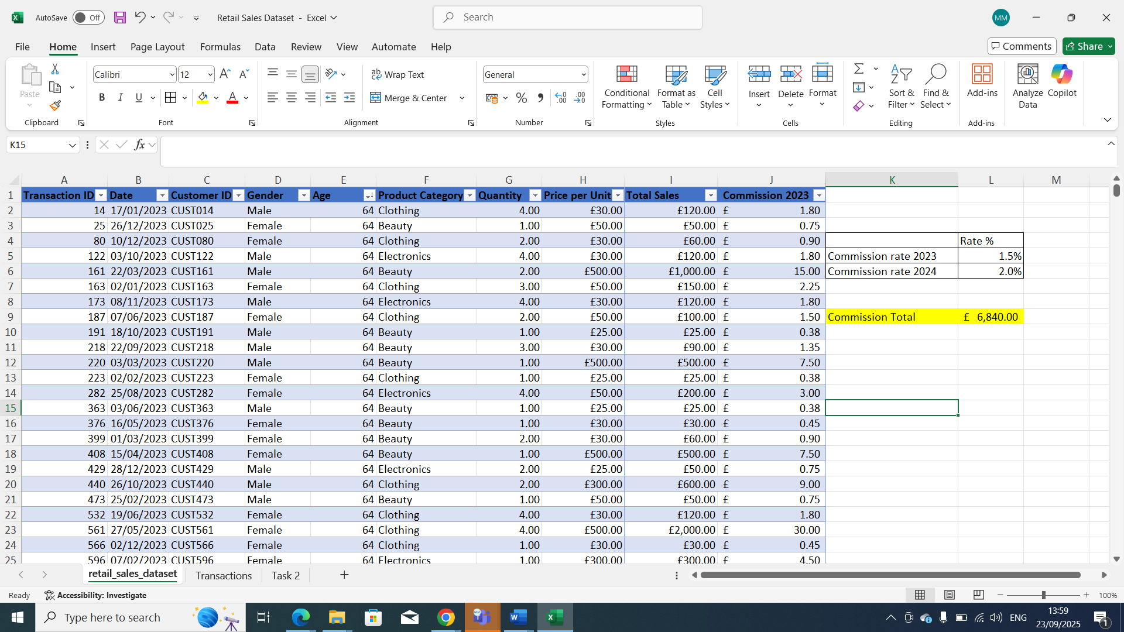
Print screen 4 | 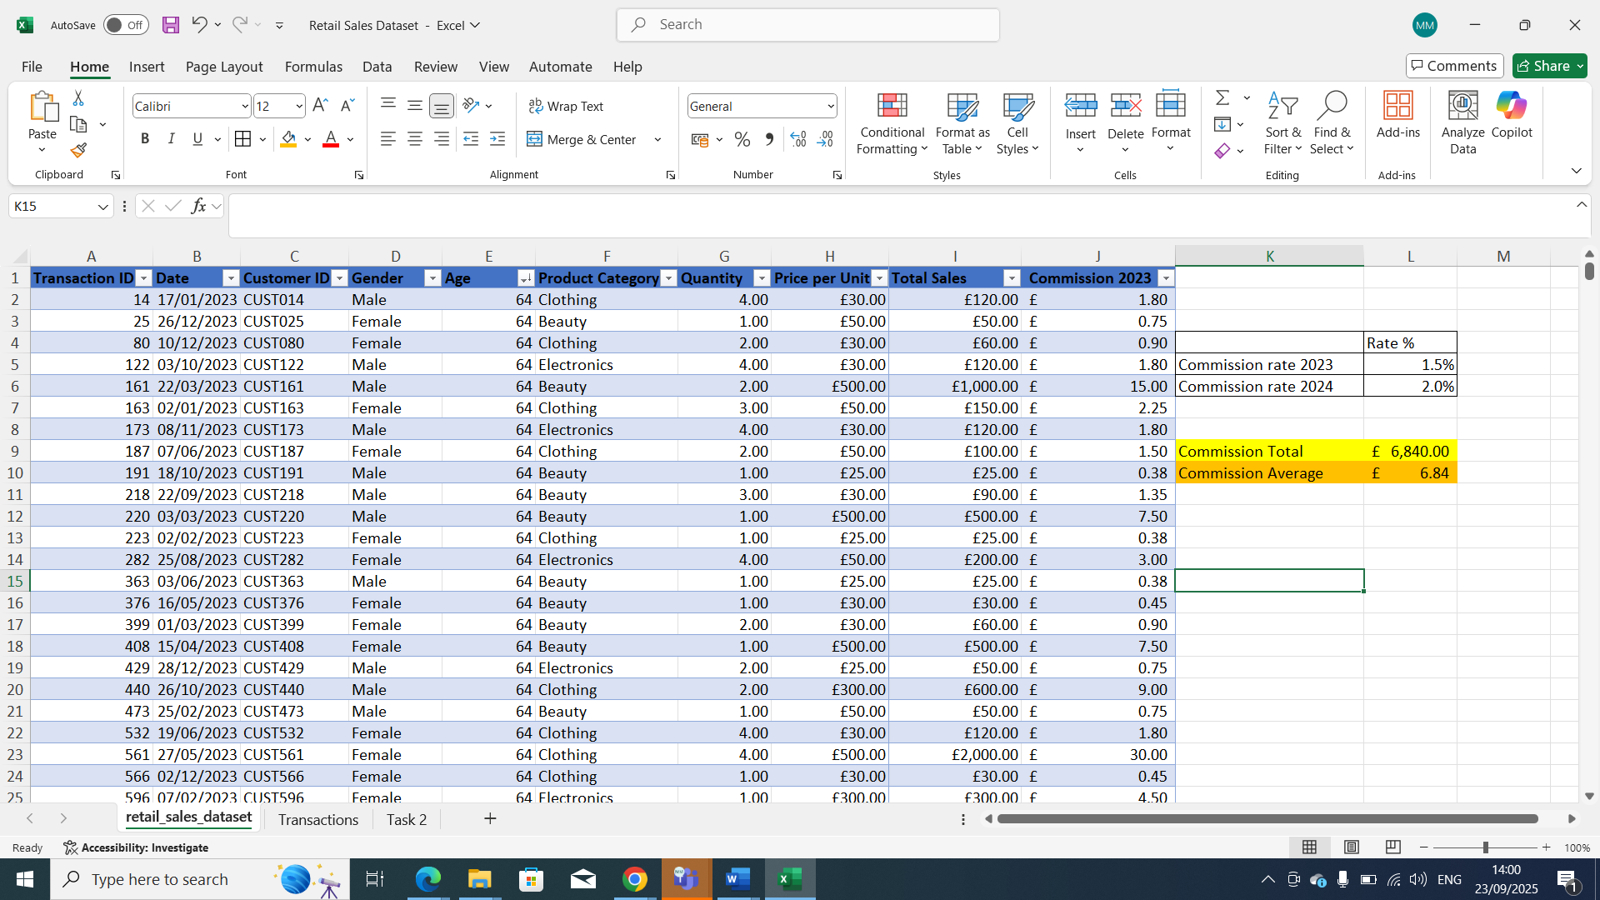

Day 2: Task 2

Please research and complete the following tasks within the retail-sales_dataset.xlsx document, paste print screens into the provided box below:

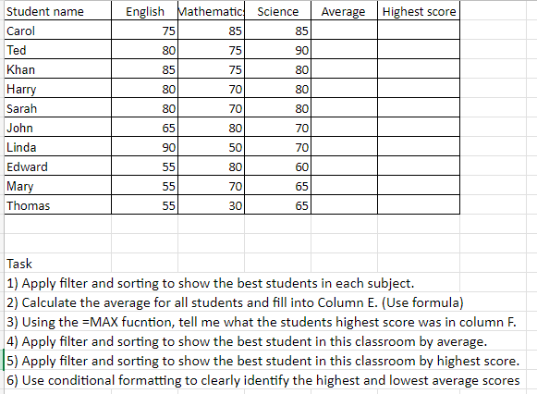

Print screen 1 | - Screenshots for individual subjects.  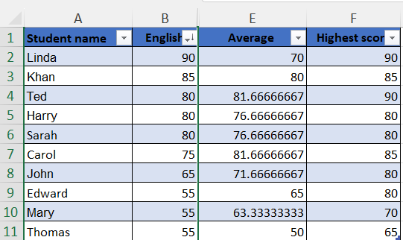  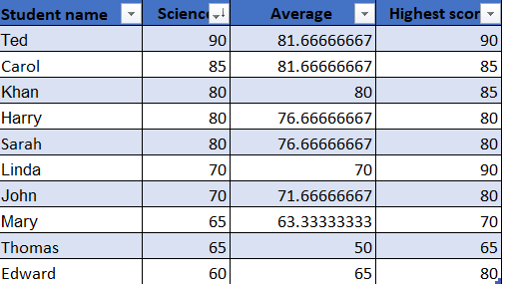  Student name Mathematics Average Highest score  Carol 85 81.66666667 85  John 80 71.66666667 80  Edward 80 65 80  Khan 75 80 85  Ted 75 81.66666667 90  Harry 70 76.66666667 80  Sarah 70 76.66666667 80  Mary 70 63.33333333 70  Linda 50 70 90  Thomas 30 50 65  - Answer to 2 & 4.  Student name English Mathematics Science Average Highest score  Ted 80 75 90 81.66666667 90  Carol 75 85 85 81.66666667 85  Khan 85 75 80 80 85  Harry 80 70 80 76.66666667 80  Sarah 80 70 80 76.66666667 80  John 65 80 70 71.66666667 80  Linda 90 50 70 70 90  Edward 55 80 60 65 80  Mary 55 70 65 63.33333333 70  Thomas 55 30 65 50 65  - Answer to 3 & 5.  Student name English Mathematics Science Average Highest score  Ted 80 75 90 81.66666667 90  Linda 90 50 70 70 90  Carol 75 85 85 81.66666667 85  Khan 85 75 80 80 85  Harry 80 70 80 76.66666667 80  Sarah 80 70 80 76.66666667 80  John 65 80 70 71.66666667 80  Edward 55 80 60 65 80  Mary 55 70 65 63.33333333 70  Thomas 55 30 65 50 65  6.  Student name English Mathematics Science Average Highest score  Ted 80 75 90 81.66666667 90  Linda 90 50 70 70 90  Carol 75 85 85 81.66666667 85  Khan 85 75 80 80 85  Harry 80 70 80 76.66666667 80  Sarah 80 70 80 76.66666667 80  John 65 80 70 71.66666667 80  Edward 55 80 60 65 80  Mary 55 70 65 63.33333333 70  Thomas 55 30 65 50 65

Day 2: Task 3

Using the skills developed today, have some fun with the data set you have imported. Paste your work below and enjoy!

Print screen 1

Day 3: Task 1

Please download the dataset ‘Day_3_Task_1_Bike_Sales_Pivot_Lab.xlsx’ from here.

The lab instructions can be found here. Do not worry if you do not complete the lab, just working with data and playing with the pivot table will be good experience.

Please paste your final pivot table below and complete the reflection questions:

Print screen 1
In which markets does Germany have customers?
What country has sales in all markets?
What are the most profitable markets by country, age group, and gender?
Any other findings?

Day 3: Task 2

The dataset below tracks the sales performance of different products in various counties in England. Please paste the dataset into a blank Excel workbook. Your task is to:
- Create a Pivot Table to summarise the data by county and product.
- Use the SWITCH function to categorise products based on their sales volume.

Dataset:
County | Product | Sales Volume
Yorkshire | Laptops | 500
Yorkshire | Smartphones | 200
Cornwall | Laptops | 700
Cornwall | Printers | 400
Lancashire | Smartphones | 150
Lancashire | Laptops | 600
Essex | Printers | 800
Essex | Smartphones | 300
Durham | Laptops | 250
Durham | Printers | 300
Greater Manchester | Smartphones | 600
Greater Manchester | Laptops | 400

Step 1: Create a Pivot Table
- Select the dataset (columns A to C).
- Insert a Pivot Table to summarise the data by County in the rows and Products in the columns. Use Sales Volume as the value to be summarised.

Step 2: Use the SWITCH Function
In a new column next to your data, use the SWITCH function to categorise products based on Sales Volume as follows:
  - For sales greater than 600: "High"
  - For sales between 300 and 600: "Medium"
  - For sales less than 300: "Low"
SWITCH Function Example:
=SWITCH(TRUE, C2 > 600, "High", C2 >= 300, "Medium", "Low")
- Apply this formula to each row, and check if the products are categorised correctly.
- In ‘Sales Volume’ you need to remove the space after each amount
- Confirm the data type is numerical

Submission:
- A completed Pivot Table summarising sales by county and product.
- A new column in the dataset categorising products by sales volume using the SWITCH function.
  - Please paste your completed work below

Print screen 1

Day 3: Task 3

Please download the dataset ‘Day_3_Task_3_Bike_Sales_Visualisations_Lab.xlsx’ from here.

The lab instructions can be found here. Do not worry if you do not complete the lab, just working with data and playing with the charts will be good experience.

Please paste your results below:

Print screen 1

Day 4: Task 1

You have been asked to deliver your analysis findings to the board of directors, within your analysis you have identified that customers are leaving your company at the 12-month point, this is typically when they receive their renewal price.

Conduct research and complete the below questions:

How would you prepare for the delivery?
What tools would you use for the delivery?
What is prospecting and why would you complete this before your delivery?
Tell me best practices for public speaking and providing updates to senior leaders
What will you show the board in your delivery?
How will you articulate the changes that are needed?
Provide a list of online resources and videos that will support your preparation for public speaking
Evaluate tools that provide visualisation.

Tell me what they are.

Tell me what you would choose when delivering your presentation and why

Course Notes

It is recommended to take notes from the course, use the space below to do so, or use the revision guide shared with the class:

Additional Information

We have included a range of additional links to further resources and information that you may find useful, these can be found within your revision guide.

END OF WORKBOOK

Please check through your work thoroughly before submitting and update the table of contents if required.

Please send your completed work booklet to your trainer.

